## Lesson 10 – Activity Sheet

## Getting Started

## Modular design is a design approach that subdivides a system into smaller parts called modules that can be independently created and then used in different systems.

In kitchen design, each unit or module is separately designed, but designed in a way that they can be re-used in different overall designs to create unique kitchens

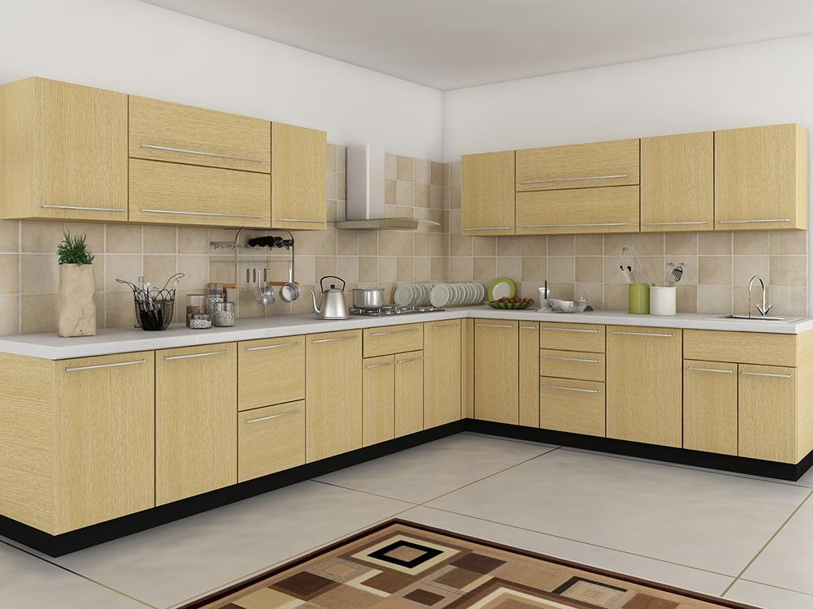

## During this task it will be your team’s job to design one or more modules for the racetrack. These modules will be fitted with your competitor’s sections to create a unique and challenging circuit.

## Success Criteria

## Design at least one section of the racetrack that will test aspects of car design (cornering, speed etc)

* Each section should include obstacles for example, barriers, gravel traps etc
* Develop a system that allows modular track sections to be connected together
* The race section should be big enough for two Bit:Bots to race around
* The racetrack must be designed to be practical to store, transport and re-assemble

## Pro-tip

## You can only use the materials provided and will need to include obstacles and barriers etc

## However – design your section to suit your car – consider its cornering ability or straight-line speed

## Good communication with your competitors will be required, but don’t give away your secrets

## Test Time

* Can your vehicle complete your own section?
* What happens if two vehicles are on the track at the same time – is there room?
* Is the track modular?
* Does it link with your competitors track?

## Stretch Tasks

* Add more complex features such as gradients
* Develop a system of storage
* Complete a set of assembly instructions or circuit map for your section

## Final Thoughts

* During today’s lesson we looked at modular design; we have planned and created a modular racetrack and had to use communication skills with our ‘competitors’ to ensure track compatibility without giving away any secrets.